ParallelandDistributedComputing

Assignment 1

Question1:DAXPYLoop

ProblemStatement:

DAXPY Loop:D stands for Double precision, A is a scalar value, X and Y are one- dimensional vectors of size 216each, and P stands for Plus. The operation performed in one iteration is:
X[i]=a×X[i]+Y[i]
Theobjectiveistocomparethespeedup(inexecutiontime)gainedbyincreasingthe number of threads starting from a 2-thread implementation.

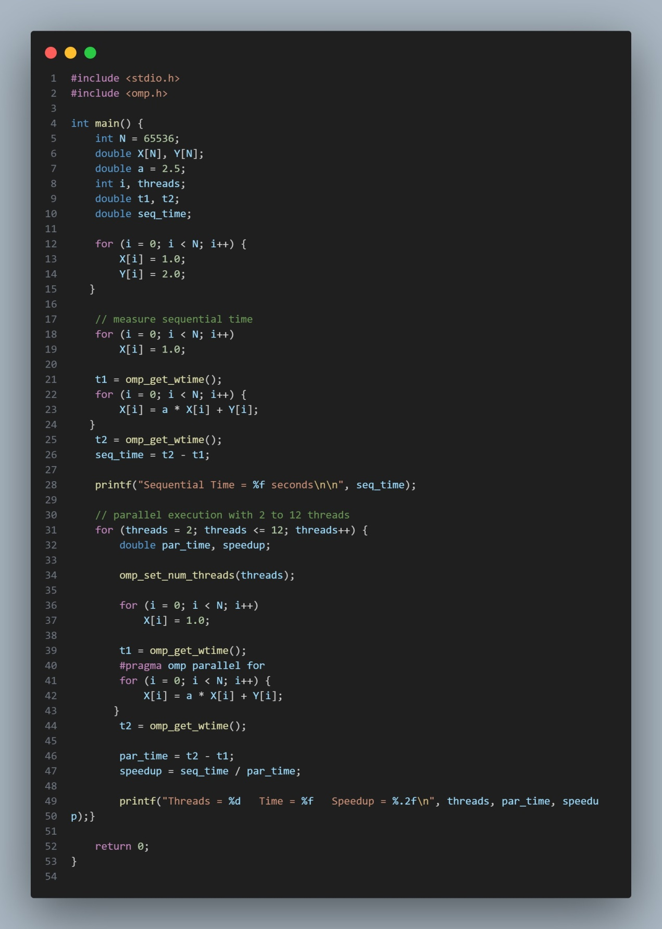

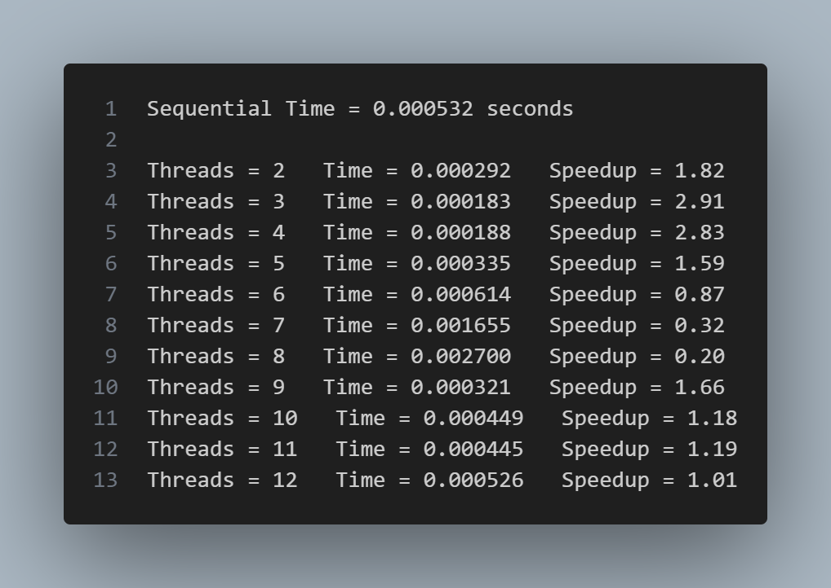

Observation
Speeduprisestill4threadsandachievesmaximumspeedupataround3–4cores(approx- imately 2.9). The synchronization overhead is small. Since the laptop has 4 physical cores, execution remains within the physical core limit.
After 4 threads (5–8 threads), a stable dip in speedup is observed.This occurs because executiongoesbeyondphysicalcoresandhyperthreadingisused.Hyperthreadingintroduces thread creation and synchronization overhead, leading to memory bottlenecks and cache conflicts.
At around 9 threads, slight recovery is observed as the scheduler adapts, but speedup remains lower than the maximum achieved.
The DAXPY loop is memory bound and executes very fast, hence overhead dominates computation.

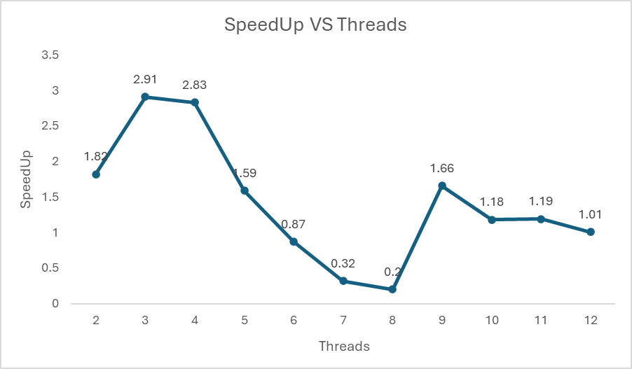

Conclusion
Bestperformanceisachievedusing1–4threadscorrespondingtophysicalcores.Beyond this point, parallelization overhead outweighs computation.

Question2:MatrixMultiplication

ProblemStatement:

Build a parallel implementation of multiplication of large matrices (e.g.,1000×1000). RepeattheexperimentfromQuestion1andanalyzeworkpartitioningamongthreadsusing:
- 1D threading

- 2D threading

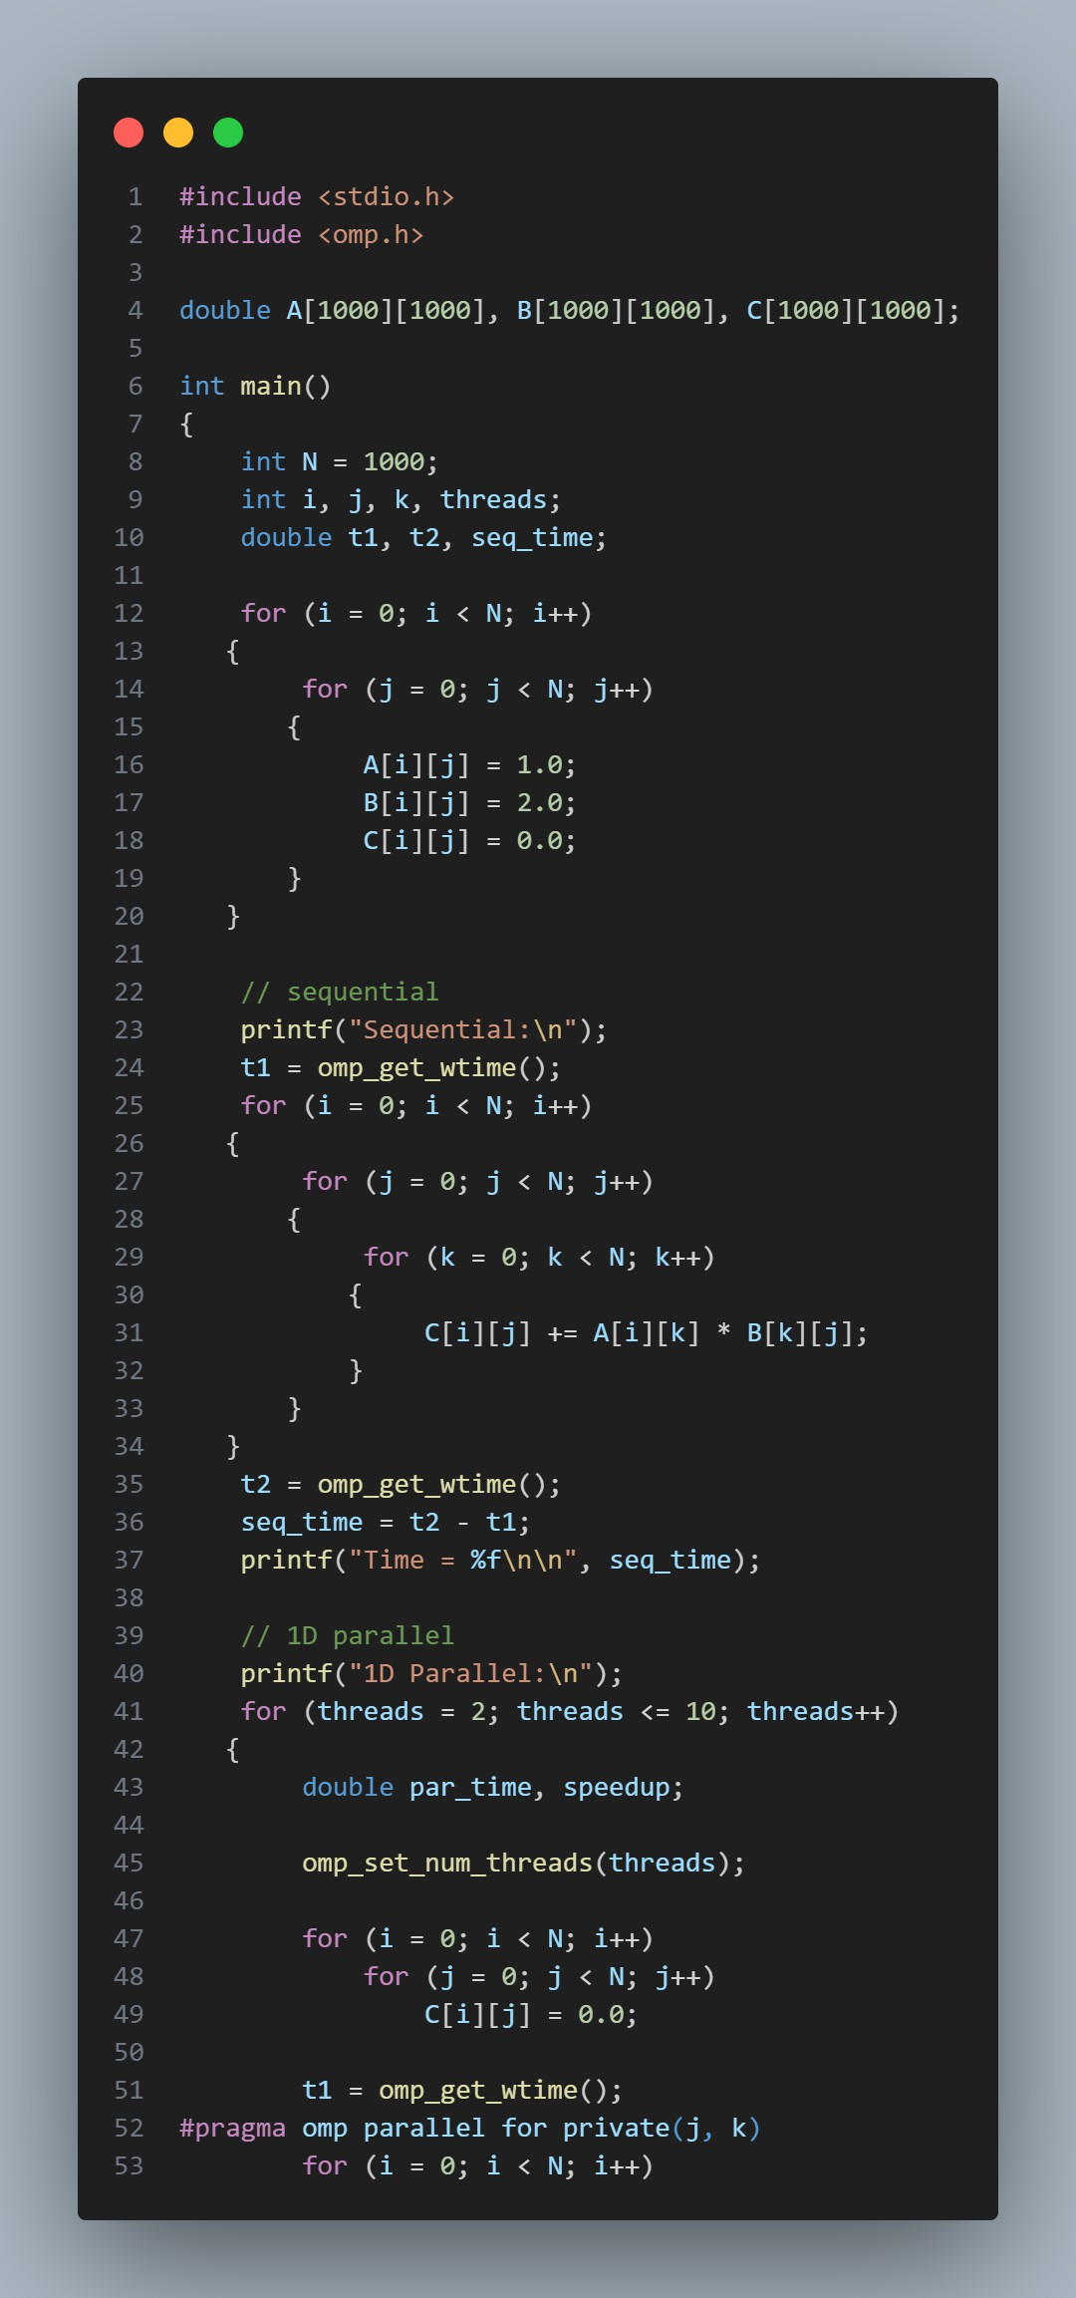

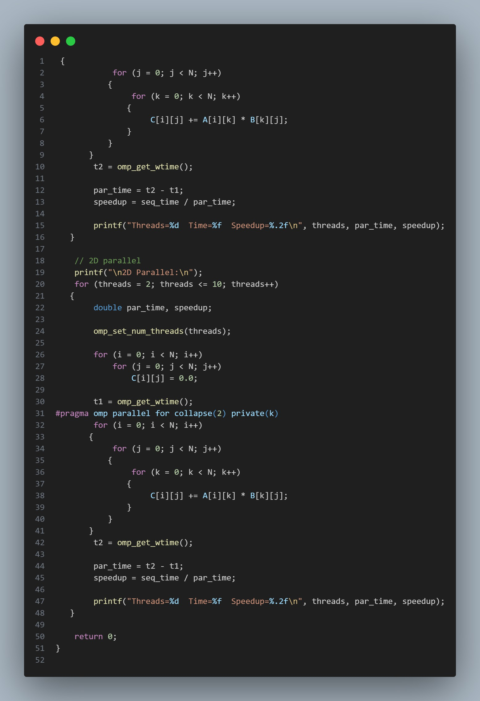

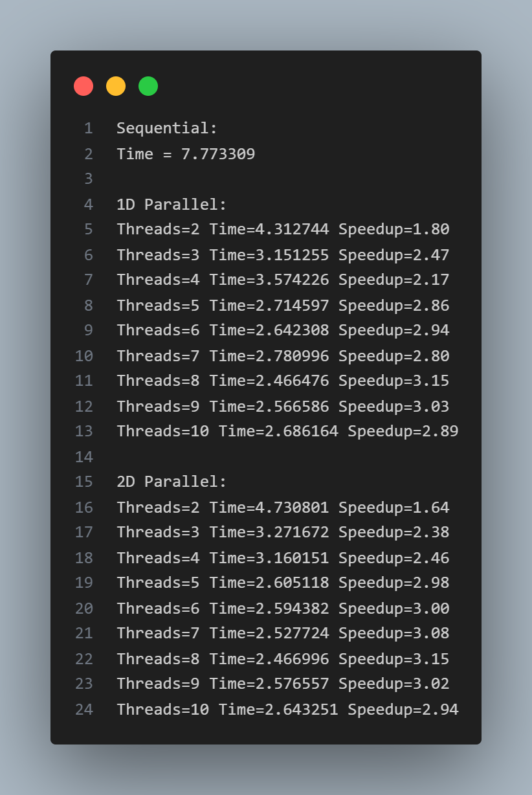

Observation
Thesequentialversionusesatriplenestedlooptocomputeeachoutputelement.
Inthe1Dparallelimplementation,theouterloopisparallelizedandeachthreadcomputes a subset of rows, resulting in low overhead.
Inthe 2D parallel implementation, both (i,j) indices are parallelized.This distributes workmoreevenlybutincreasesschedulingoverhead.
For2–3threads,overheaddominatesand1Dperformsbetter.For4–8threads,2Dslightly outperforms1Dduetoimprovedloadbalancing.Cacheeffectsandmemorybandwidthlimit perfect scaling.

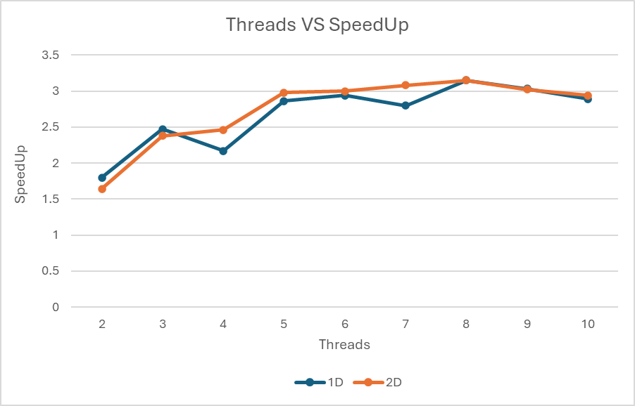

Conclusion
Both 1D and 2D implementations are correct and scale well up to logical cores.Similar performance is observed due to moderate workload size.

Question3:Calculationofπ

ProblemStatement:

Thevalueofπiscomputedusingnumericalintegration:
π=∫14 dx
01+x²

The integral is approximated using the rectangle method and parallelized using OpenMP reduction.

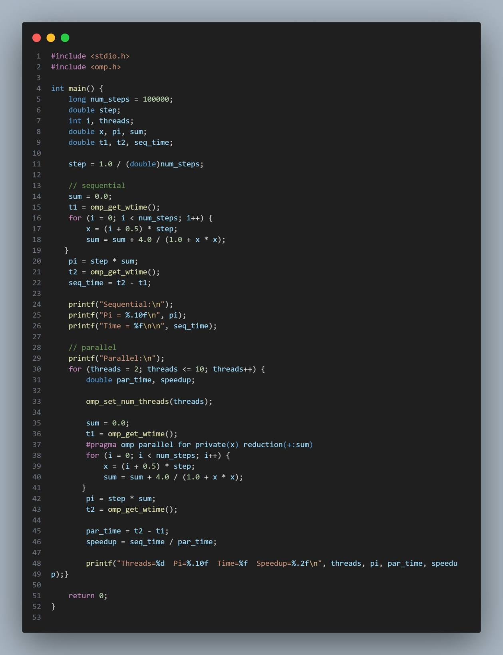

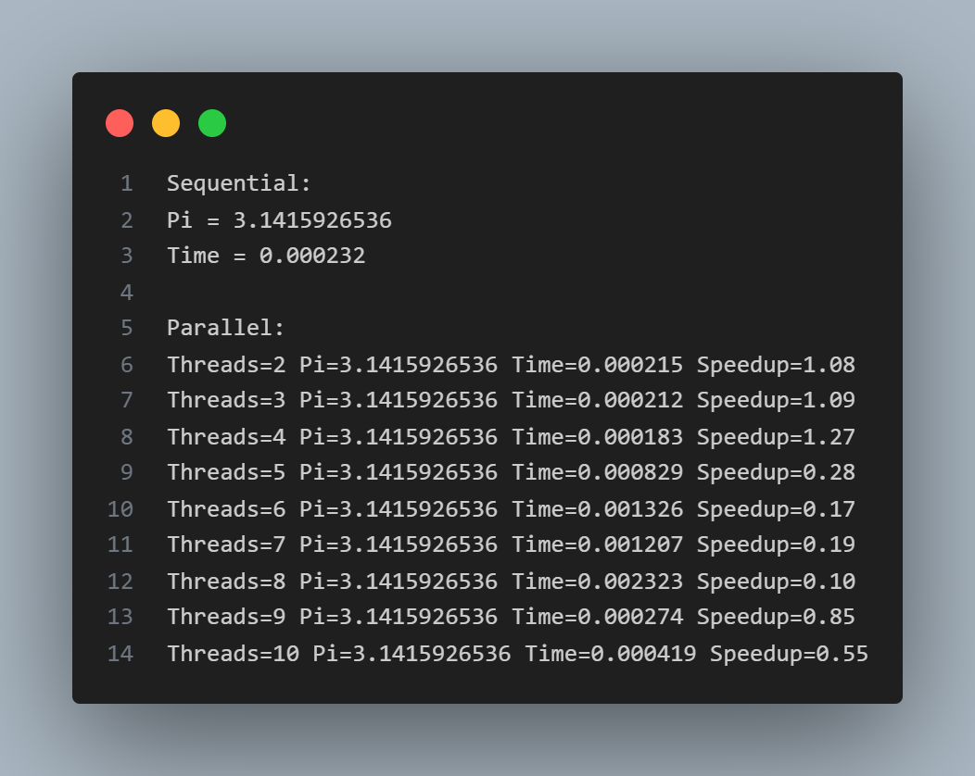

Observation
Theloopiterationsaredividedamongthreadsandpartialsumsarecombinedusing
reduction(+:sum),avoidingraceconditions.
Maximum speedup is small (∼1.27) because the sequential execution time is extremely small.For 2–4 threads, speedup increases gradually.
For 5–8 threads, speedup drops due to synchronization overhead, cache contention, and reductioncosts.Aslightrecoveryathigherthreadcountsisattributedtoschedulingeffects.

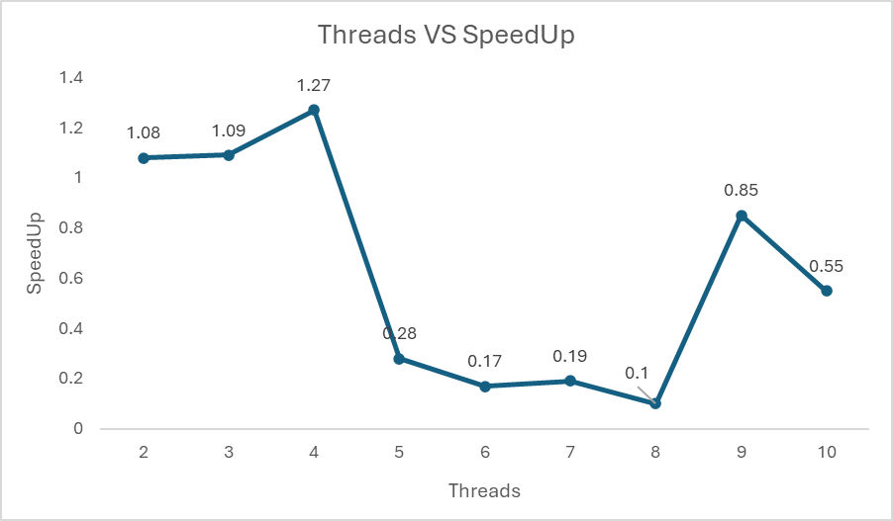

Conclusion
The program computes an accurate approximation of π.Parallelism is beneficial only up to physical cores, after which overhead dominates.

Submitted to :Dr Saif Nalband Submitted by :Gautam Tayal
Roll No.:102483024

